We initially start by uploadin the dataset into hdfs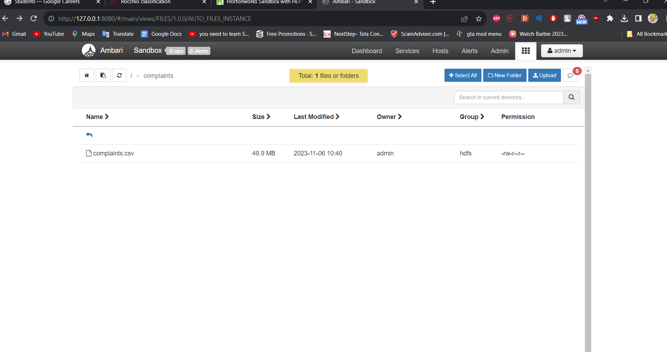

Now we get the file into local by using -get command and start pig, once the environment is ready we begin by creating an organised dataset to upload the .csv file

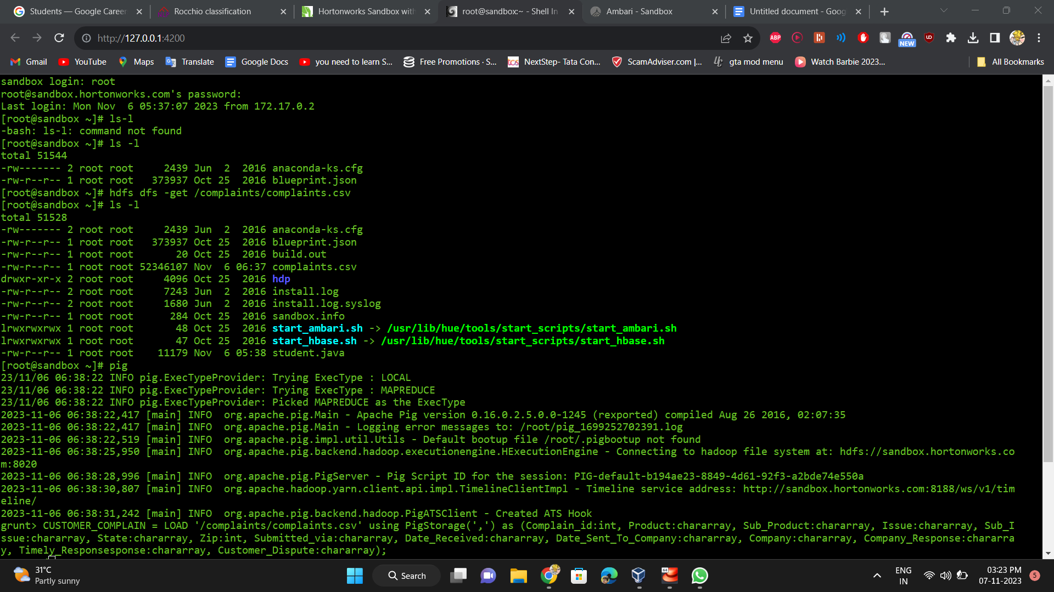

We begin by making the insights on complaints based on company

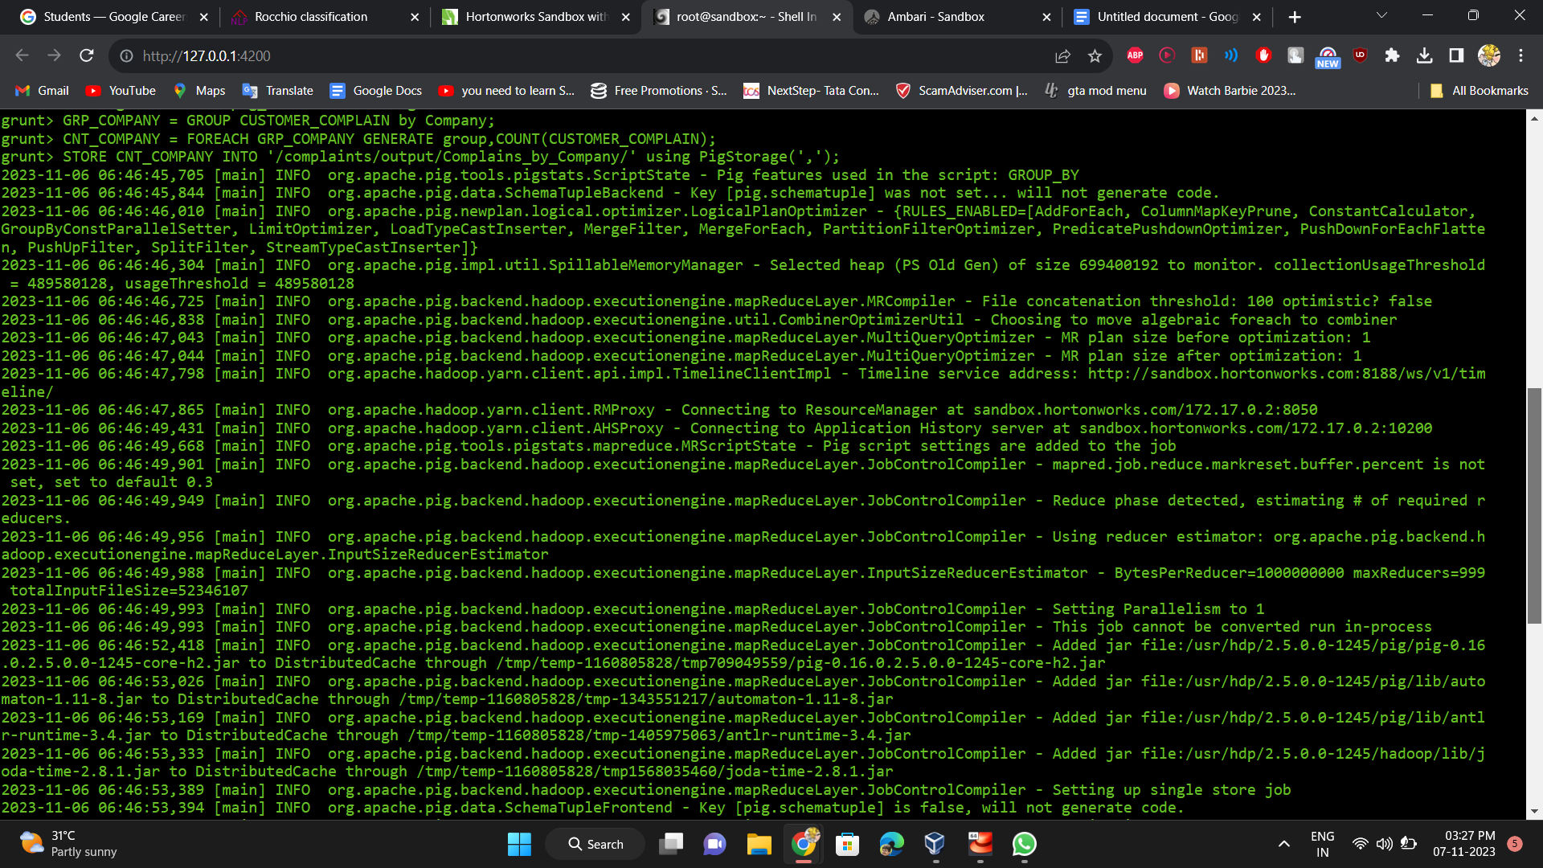

This the the output based on the script and is stored in /complaints/output folder

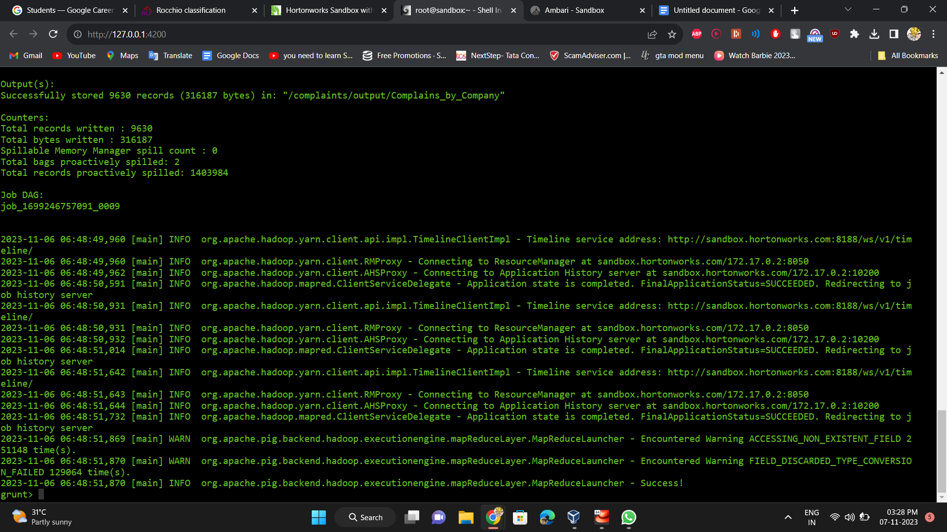

We use the script in gaining the insights on complaints based on product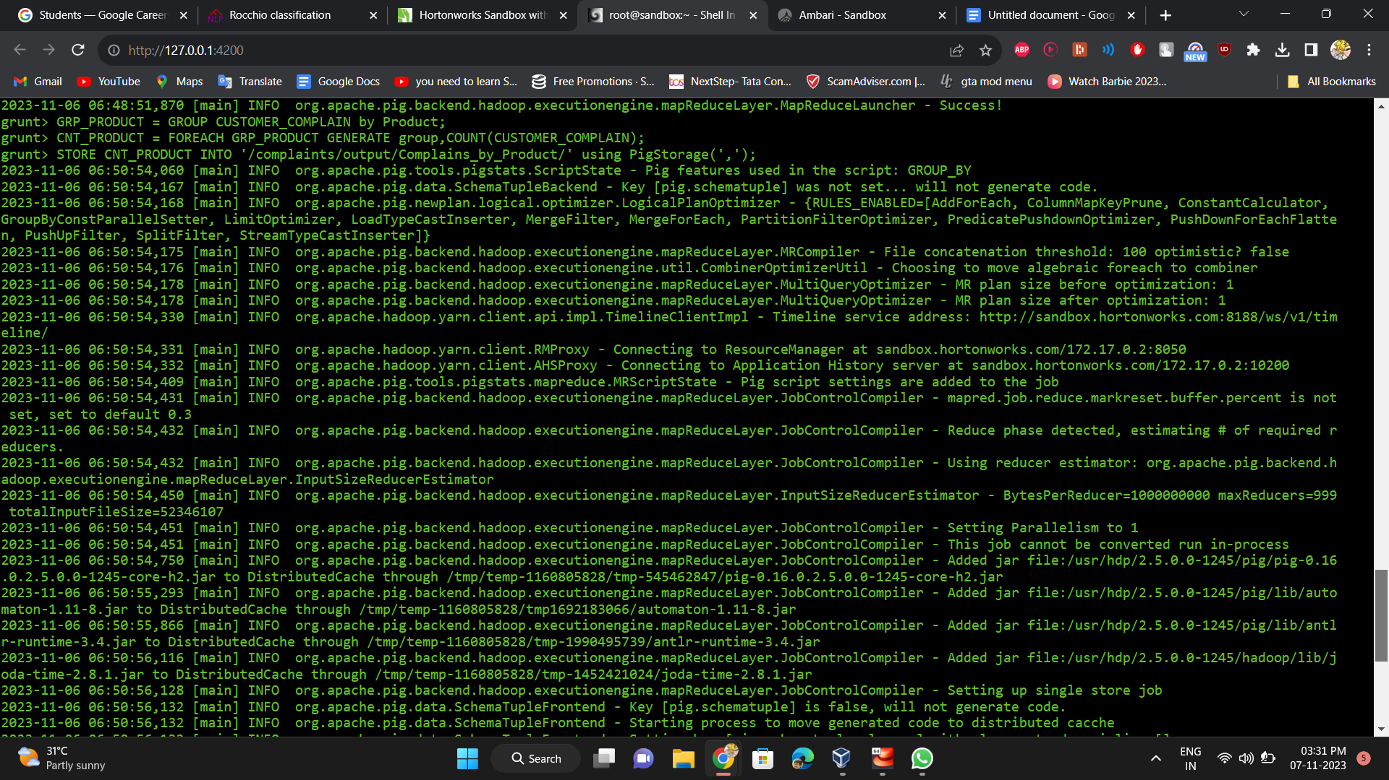

This the the output based on the script and is stored in /complaints/output folder

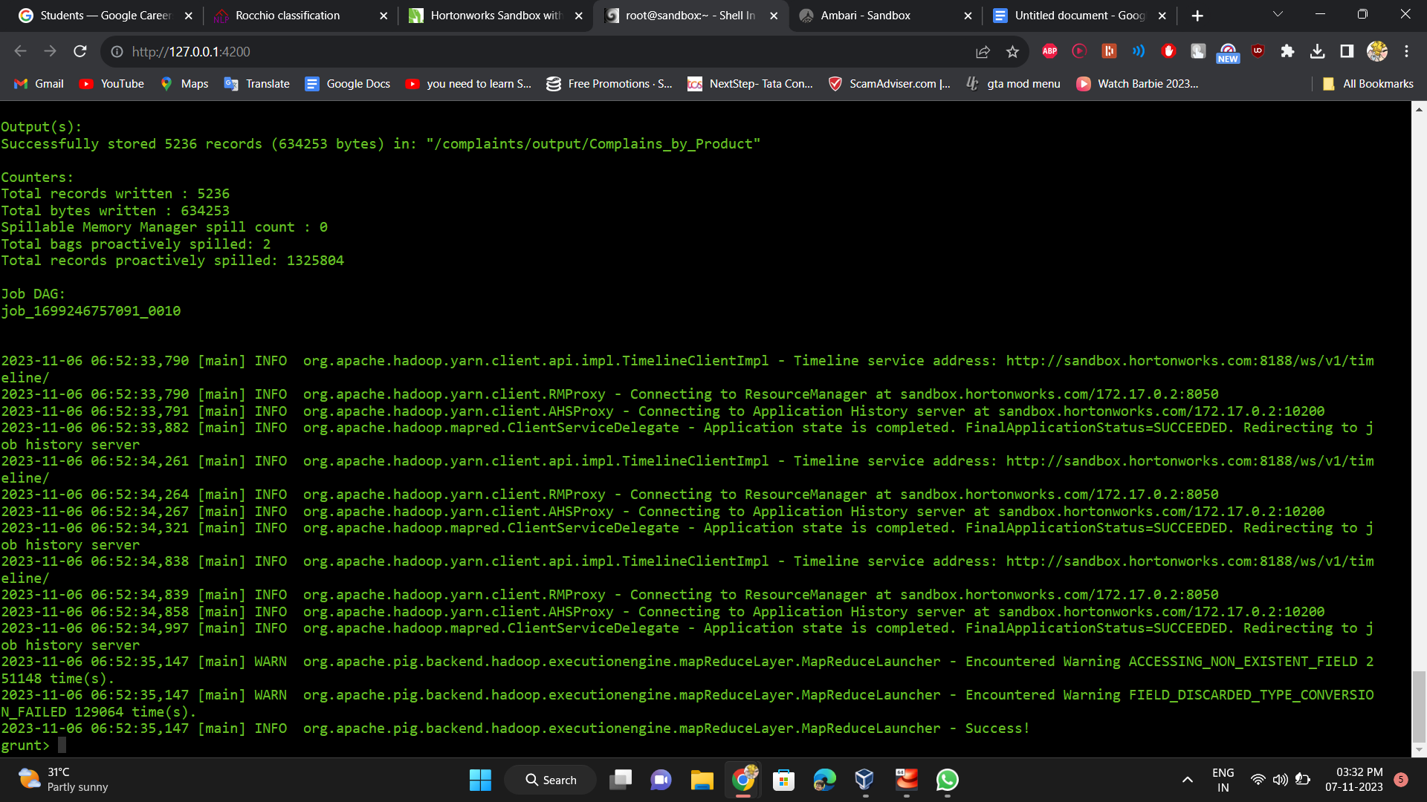

We use the script in gaining the insights on complaints and provides the address and location of the companies

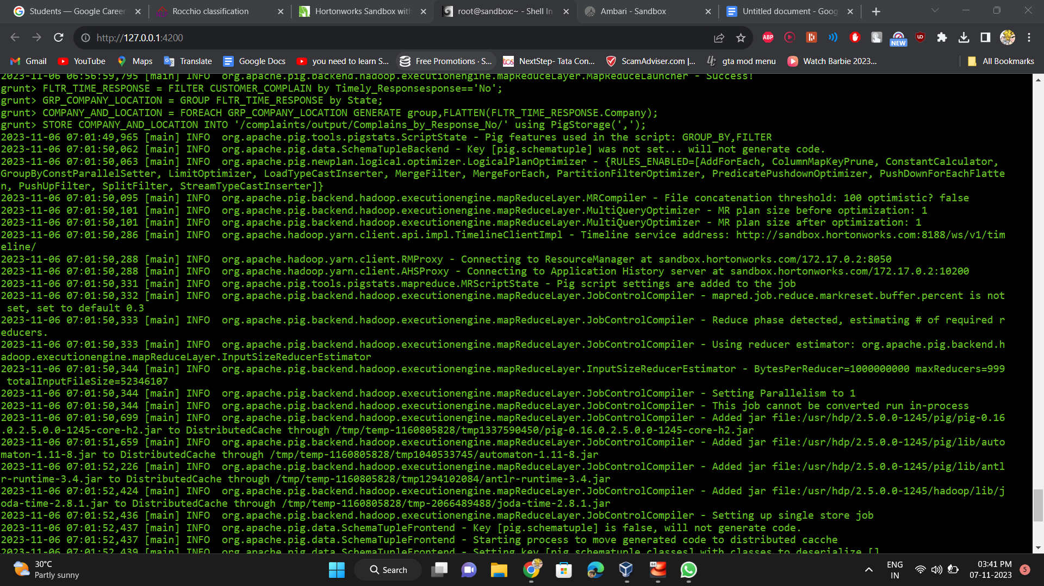

This the the output based on the script and is stored in /complaints/output folder

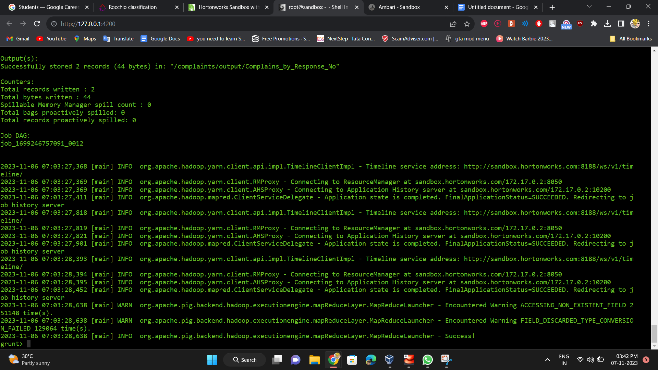

We managed tto get the outputs as aboe folders the output conytains in the file part-r-00000